Heat Illness Prevention Guideline

Ref: OSHA’s Using the Heat Index: A Guide for Employers

NIOSH’s Heat Stress Recommendations

Facility:

Administrator:

Last Revised Date:

Next Revision Date:
TABLE OF CONTENTS

- Purpose Pg. 1

- Scope pg. 1

- Maintenance pg. 1

- Definitions pg. 1 – 3

- Discussion

  - Responsibilities
    - Location Managers PG. 3
    - Safety Coordinator PG. 3
    - Supervisors/Managers PG. 3
    - Team Members PG. 3 – 4
  - Risk Factors PG. 4 – 5
  - Heat Related Illnesses
    - Heat Cramps PG. 5
    - Heat Rash Pg. 5
    - Heat Exhaustion pg. 5 – 6
    - Heat Stroke pg. 6
  - Preventing Heat Related Illnesses
    - General PG. 6 – 9
    - Actions for low risk (80-91˚F) pg. 9
    - Actions for moderate risk (91-103˚F) pg. 9
    - Actions for high risk (103-115˚F) pg. 9
    - Actions for very high risk (>115˚F) pg. 9 – 10
  - Training PG. 10

- Reference PG. 10

- Attachments PG. 10

I. PURPOSE

The objective of this policy is to reduce the risk of illness, injury or fatality to __________ employees from heat-related disorders.

II. SCOPE

This plan implements efficient and safe work practices that will prevent both indoor and outdoor heat-related illnesses among employees at our workplace. It will be used for training new employees and for the annual refresher training of employees. All employees potentially exposed to hot working environments are subject to his plan.

III. MAINTENANCE

The local Safety Manager, or their designee, is in charge of reviewing the program periodically.

IV. DEFINITIONS

Acclimatization: The temporary adaptation of the body to work in the heat that occurs gradually when a person is exposed to it. Acclimatization peaks in most people within four to fourteen days of regular work for about two hours per day in the heat.

Environmental risk factors for heat illness: The working conditions that create the possibility that heat illness could occur, including air temperature, relative humidity, radiant heat from the sun and other sources, conductive heat sources such as the ground, air movement, workload severity and duration, protective clothing and personal protective equipment worn by employees.

Heat Cramps: painful, muscle spasms typically the result of hard physical labor in a hot environment.

Heat Exhaustion: weakness, dizziness, or nausea often resulting from the combination of excessive heat and dehydration. If untreated, this can lead to heat stroke.

Heat Illness: A serious medical condition resulting from the body’s inability to cope with a particular heat load, and includes heat cramps, heat exhaustion, heat syncope, and heat stroke.

Heat Index: a single value that takes both temperature and humidity into account to show how hot the weather will feel. This is a better measure for estimating the risk to employees than just temperature alone.
- Strenuous work and the use of heavy or specialized protective clothing will increase the amount of heat the employees feel.

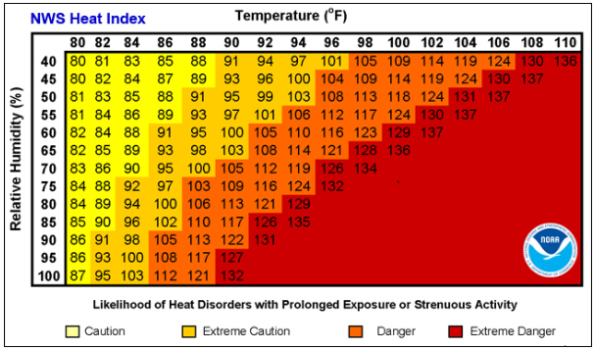

Heat Rashes: redness of skin resulting from continuous wetting of clothing from sweat

Heat Stress: When the body is unable to cool itself by sweating, several heat-induced illnesses such as heat cramps, heat exhaustion, heat stroke, or even death can occur.

Heat Stroke: the most serious disorder associated with heat stress, can cause severe headaches, high fever, collapse, or coma.

Personal risk factors for heat illness: Factors such as an individual’s age, degree of acclimatization, health, water consumption, alcohol consumption, and caffeine consumption.

Preventative recovery period: A period of time to recover from the heat in order to prevent heat illness.

Relative Humidity: a measure of how much moisture is in the air; sweat does not evaporate as quickly when the air is moist vs dry.

Rest period: a break from the work area with the elevated temperature to an area that is cooler, should be taking in fluids at this time. This time can be used for the employee to do paperwork or other light duty in a cool environment.

Shade: The blockage of direct sunlight. Canopies, umbrellas, and other temporary structures or devices may be used to provide shade. One indicator that blockage is sufficient is when objects do not cast a shadow in the area of blocked sunlight. Shade is not adequate when heat in the area of shade defeats the purpose of shade, which is to allow the body to cool. For example, a car sitting in the sun does not provide acceptable shade to a person inside it, unless the car is running with air conditioning.

V. DISCUSSION

A. Responsibilities

1. Location manager or his/her representatives

The Local Manager has the overall responsibility of implementing the Heat Illness Prevention Program.

2. Safety Manager

It is the responsibility of the Safety Manager to implement this program by:

- Preparing and maintaining a written program, which complies with the requirements.
- Providing training to all potentially impacted employees and their supervisors on the risks and prevention of heat illness, including how to recognize symptoms and respond when they appear. Training should be provided annually, and as a refresher prior to the start of the summer season.
- Identifying all employees who are required to work outdoors/indoors where potential heat illness could occur and identifying the supervisor(s) of the employees.

3. Supervisors/Managers

Supervisors/Managers are responsible for:

        - Assuring that adequate water and shade are available at a job site when the environmental risk factors for heat illness are present.
        - Ensuring that all affected employees have received proper training on heat illness prevention.
        - Ensuring that the requirements in this program are followed.

4. Team Members

It is the responsibility of all Team Members to:

- Comply with the provisions of the Heat Illness Prevention Program, as described in this document and in the training sessions they attend.
- Ensure they have drinking water available at all times when the environmental risk factors for heat illness are present.
- Ensure they have access to a shaded area to prevent or recover from heat related symptoms.
- Report heat-related illness symptoms to their supervisor.
- Look for the signs and symptoms of heat stress on co-workers.

B. Risk Factors

- The following are environmental risk factors for heat illness (see heat index in the Definitions section of this program):

  - Air temperature above 90 degrees F.
  - Relative humidity above 40 percent
  - Radiant heat from the sun and other sources
  - Conductive heat sources such as dark-colored work surfaces
  - Lack of air movement
  - Physical effort needed for the work
  - Use of nonbreathable protective clothing and other personal protective equipment

- The following are personal risk factors for heat illness:

  - Lack of acclimation to warmer temperatures
  - Poor general health
  - Dehydration
  - Alcohol consumption
  - Caffeine consumption
  - Previous heat-related illness
  - Use of prescription medications that affect the body’s water retention or other physiological responses to heat such as beta blockers, diuretics, antihistamines, tranquilizers, and antipsychotics.

C. Heat Related Illnesses

- Heat Rash
Heat rash is the most common health problem in hot work environments. It is caused by sweating and looks like a red cluster of pimples or small blisters. Heat rash usually appears on parts of the body that overlap or rub other parts of the body, such as in the groin area, under the arms or breasts, and in knee or elbow creases. If an employee has symptoms of heat rash, provide a cooler, less humid work environment, if possible. Advise the employee to keep the area dry and not to use ointments and creams that make the skin warm or moist, which can make the rash worse.

- Heat Cramps
Heat cramps are painful, involuntary muscle spasms that usually occur during heavy exercise in hot environments. The spasms may be more intense and more prolonged than are typical nighttime leg cramps.

Fluid and electrolyte loss often contribute to heat cramps.
Muscles most often affected include those of your calves, arms, abdominal wall and back, although heat cramps may involve any muscle group involved in exercise.

If an employee is experiencing signs or symptoms of heat cramps, have them:

- Rest briefly and cool down,
- Drink clear juice or an electrolyte-containing sports drink,
- Practice gentle, range-of-motion stretching and gentle massage of the affected muscle group,
- Not resume strenuous activity for several hours or longer after heat cramps go away

- Heat Exhaustion
Heat exhaustion can best be prevented by being aware of one’s physical limits in hazardous environment on hot, humid days. The most important factor is to drink enough clear fluids (especially water, not alcohol or caffeine) to replace those lost to perspiration.

Signs and symptoms of heat exhaustion typically include:
    - Profuse sweating
    - Weakness and fatigue
    - Nausea and vomiting
    - Muscle cramps (associated with dehydration)
    - Headache
    - Light-headedness or fainting; fainting or loss of consciousness is potentially serious and should be treated as a medical emergency.

When you recognize heat exhaustion symptoms in an employee, you must intervene:
- stop the activity and move the employee to a cooler environment.
- Cooling off and rehydrating with water (or electrolyte- replacing sports drinks) is the cornerstone of treatment for heat exhaustion.
- If the employee resumes work before their core temperature returns to normal levels, symptoms may quickly return.

If there is no intervention and the body’s temperature regulation fails, heat exhaustion can rapidly progress to heat stroke, a life-threatening condition.

- Heat Stroke
Heat Stroke requires an immediate emergency medical response. The person may stop sweating, become confused or lethargic, and may even have a seizure. The internal body temperature may exceed 106˚F.

Signs and symptoms of heat stroke typically include:

- Absence of sweating
- Dry skin
- Agitation or strange behavior
- Dizziness, disorientation, or lethargy
- Seizures or signs that mimic those of a heart attack

If an employee is experiencing signs or symptoms of heat stroke:
      - Ensure that emergency responders are summoned immediately if heat stroke is suspected.

      - While waiting for emergency responders to arrive, cool the employee by:

        - moving the employee to an air-conditioned environment or a cool, shady area,
        - helping the employee remove any unnecessary clothing, and
        - do not leave the employee unattended.

Heat stroke requires immediate medical attention to prevent permanent damage to the brain and other vital organs that can result in death.

D. Preventing Heat Related Illnesses

- General Actions:
  - Monitor weather reports daily and reschedule jobs with high heat exposure to cooler times of the day, if possible. Be extra vigilant when air temperatures rise quickly. When possible, schedule routine maintenance and repair projects for the cooler parts of the year

  - Become familiar with the risk factors associated with the heat index and the measure that can be taken.
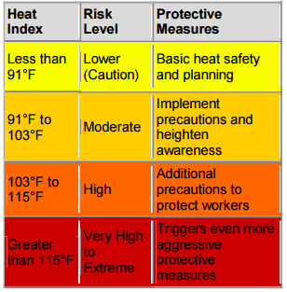

  - Check heat stress monitor before employees begin work in suspect areas.
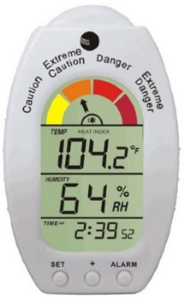
Example Heat Stress Monitor

  - Gradually increase workloads and allow more frequent breaks during the first week of work so that employees become acclimatized to higher temperatures, especially those who are new to working in the heat or have been away from that work for a week or more.

  - Educate employees in these areas on the steps they need to take when the heat index is at or above 80˚F. These may include:
    - Encourage employees to frequently drink small amounts of water before they become thirsty to stay hydrated.
    - Encourage employees to monitor their hydration with a urine chart. Urine should be clear or slightly colored; dark urine is a warning sign.
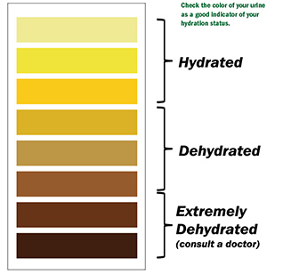
    - Encourage employees to eat regular meals and snacks as they provide enough salt and electrolytes to replace those lost through sweating as long as enough water is consumed.
    - Ensure employees are aware of the signs of heat-related illnesses and encourage them to report immediately they or their co-workers show symptoms.

- Actions for low-risk conditions 80-91˚F
  - Provide drinking water

- Actions for Moderate risk conditions 91-103˚F
  - Supervisors should be monitoring employees for signs of being affected by the heat
  - Encourage employees to drink 4 cups of water per hour
  - Review the signs and symptoms of heat exhaustion and heat stroke
  - Whenever possible, have breaks every 30 minutes where the worker retreats to a cooler, air-conditioned place for 5 minutes.
  - For outside work, cooling stations should be set up whenever possible (tents, Gatorade/water coolers, misting fans, etc.).

- Actions for High-risk conditions 103-115˚F
  - Alert employees to high-risk conditions
  - Encourage employees to drink 4 cups of water per hour
  - When possible, reschedule activities to a time when the heat index is lower.
  - Enforce the work/rest schedule (-have breaks every 30 minutes where the worker retreats to a cooler, air-conditioned place for 5 minutes)
  - If available, wear cooling vest or other provided items for cooling
  - Department Managers/Supervisors will watch/communicate with employees at all times.

- Actions for Very high/extreme risk conditions >115˚F
  - Reschedule non-essential activities for when the heat index is lower
  - Permit only those employees more acclimated to the heat to perform the more strenuous tasks
  - Add extra personnel to physically demanding tasks
  - Alert employees to extreme heat conditions
  - When possible, rotate employees on job tasks
  - Set up a buddy system where employees encourage each other to drink water, use shade to stay cool, and to watch each other for symptoms of heat-related illness.

- Training

Initial training is conducted during the Safety portion of new hire training and
annually thereafter prior to start of the summer season.
.

VI. REFERENCES

https://www.osha.gov/heat
https://www.cdc.gov/niosh/topics/heatstress/default.html

VII. ATTACHMENTS

There are no attachments for this program, but there are several training materials and postings that can be found here:

https://www.osha.gov/heat
https://www.cdc.gov/niosh/topics/heatstress/default.html

